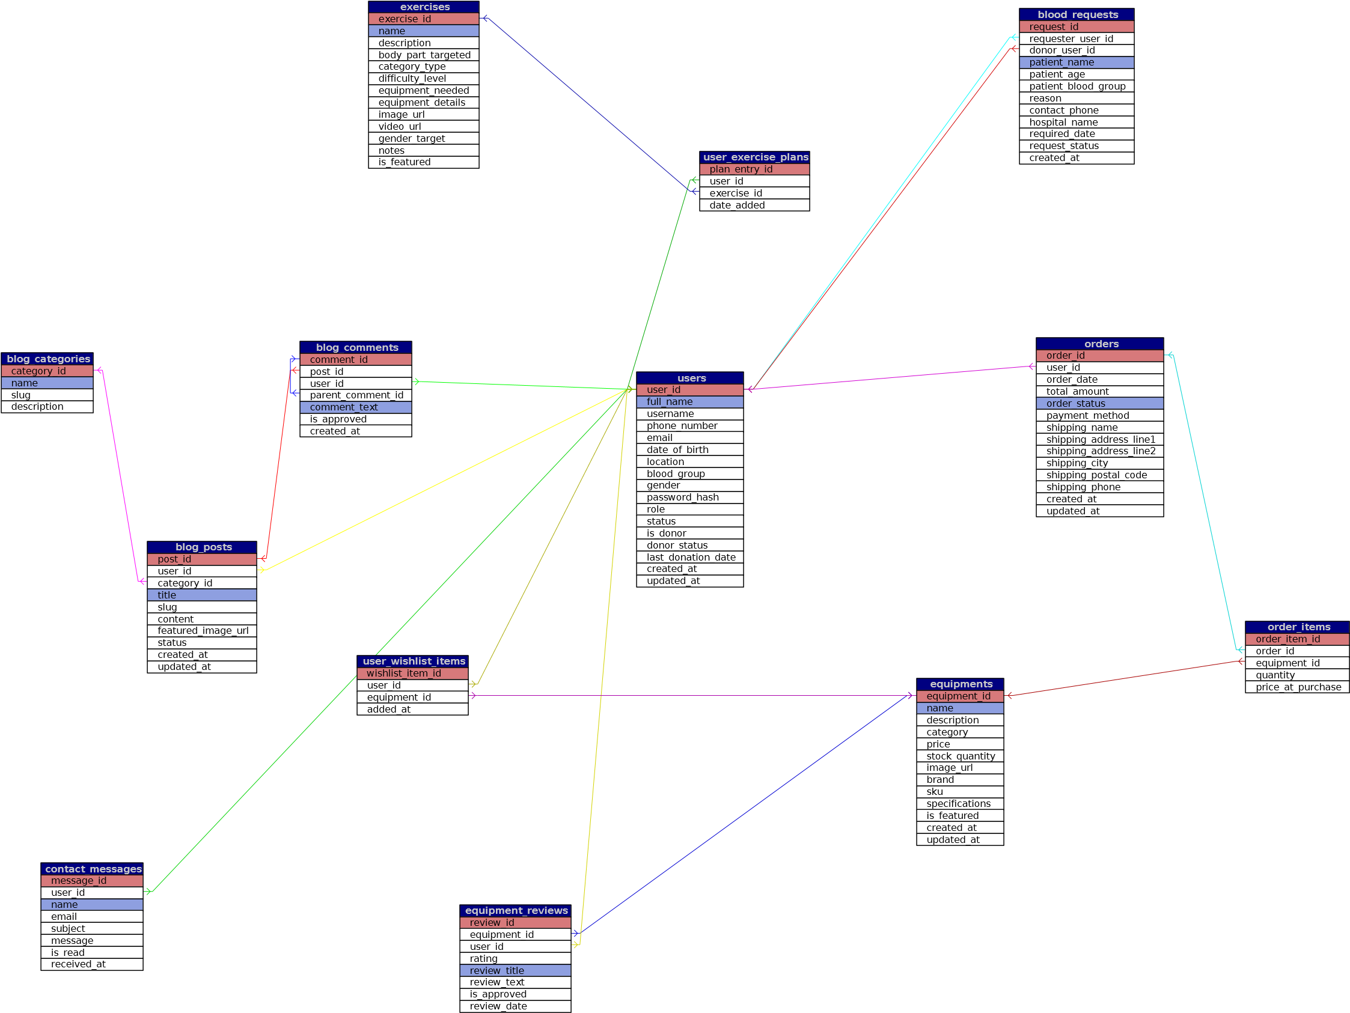
Powered by TCPDF (www.tcpdf.org)

